Alex Vo

June 19, 2022

MongoDB Atlas: Setup

Cluster setup

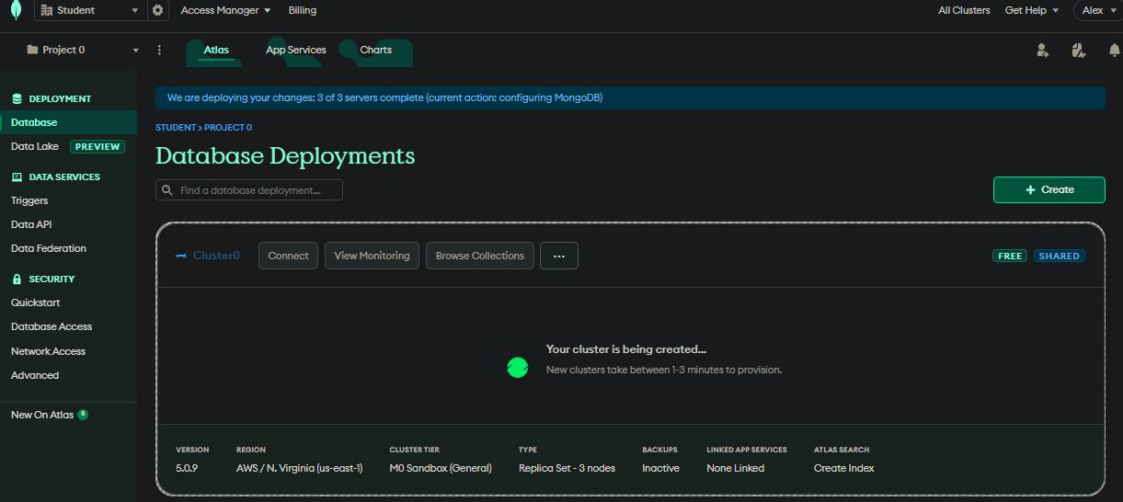

Project setup

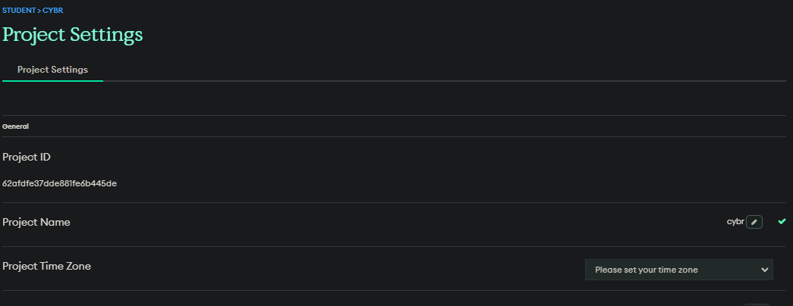

User setup

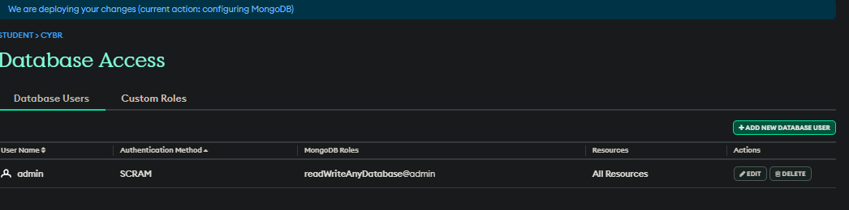

Ip address added

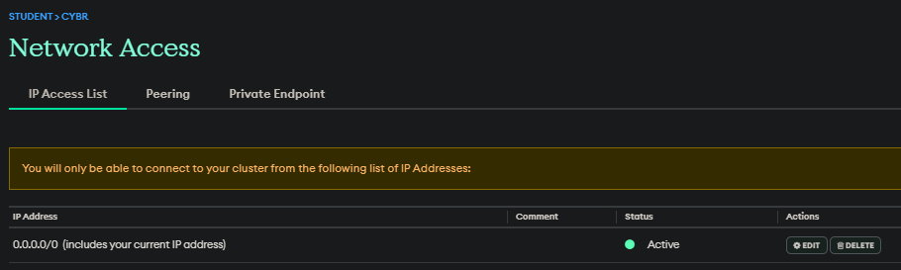

Collections view

